Turn off notifications for calendar events in Teams
(so that you won’t get them from both Teams and Outlook)

- Go to the settings for Teams by clicking on the three dots next to your profile picture and select Settings.
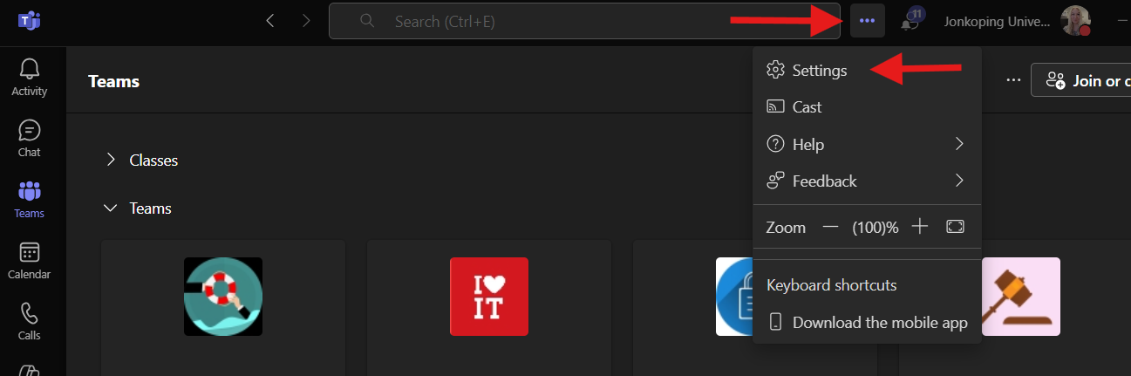
- Select Notifications and activity in the menu, scroll down to calendar and turn off the two options
